
FACULTY OF ENGINEERING AND TECHNOLOGY

A REPORT ABOUT THE MATLAB ASSIGNMENT ONE AND TWO

PRESENTED TO THE COURSE LECTURER OF COMPUTER PROGRAMMING:
MR MASERUKA BENEDICTO

SUBMITTED BY GROUP 5

Date of submission…. /…. /…

ACKNOWLEDGEMENT
First and foremost, we would like to thank The Almighty God for guiding and helping us to carry on with our assignment as group 5 members. We would like to extend our gratitude to all the persons with whose help we managed to make this far.
The willingness of each one of us to invest time and provide constructive feedback has been immensely valuable in this assignment. Finally, we would like to express our gratitude to all the sources and references that we used.

ABSTRACT
As group 5, we met in the university library and discussed about our assignment which boosted our exposure to various codes in addition to the acquired knowledge from the previous lectures. Our discussion and research as a group helped us come up with a solution for the given assignment.

DECLARATION
We hereby certify and confirm that the information in this group is out of our own efforts, research and it has never been submitted in any institution for any academic award.
GROUP 5 MEMBERS
NAME | REGISTRATION NO. | COURSE | SIGNATURE
KEMIGISA TASHA CAROLINE | BU/UG/2024/5056 | AMI
AYEBARE PRUDENCE | BU/UP/2024/1022 | WAR
KENYI MOSES | BU/UP/2024/5344 | MEB
ZZIMBE ENOCK | BU/UP/2024/4455 | WAR
OKETCH SIMON | BU/UP/2024/0841 | AMI
NAKYAGABA BARBRA | BU/UP/2024/4328 | APE
KABUGIRI PEARL FLAVIA | BU/UP/2024/4450 | WAR
OMALI EMMANUEL | BU/UP/2024/1062 | WAR
OYUGI ANDREW LINUS | BU/UP/2024/1068 | WAR
KAGOYA ANN LAURIENE | BU/UP/2024/0996 | PTI

Date: ………………………

DEDICATION
We dedicate this report to all individuals especially group 5 members, who have been there for us in the process of formulating and producing this report. To our lecturer Mr. Maseruka Benedicto whose guidance and expertise have been invaluable, mentorship and insightful feedback have shaped our understanding.

APPROVAL
This is to confirm that this report has been written and presented by GROUP 5, giving the details of the first MATLAB assignment and what we learnt.
LECTURER
NAME: …………………………………..
SIGNATURE: …………………………
DATE: ……………………………………

TABLE OF CONTENTS
ACKNOWLEDGEMENT 2
DECLARATION 5
DEDICATION 6
1.0 CHAPTER ONE 9
1.1 NUMBER ONE 9
2.0 CHAPTER TWO 13
2.1 NUMBER TWO 13
3.0 CHAPTER THREE 17
3.1 CONCLUSION 17

1.0 CHAPTER ONE
  - NUMBER ONE
Kaggle.com
Assignment 1
- Each group should be able to retrieve a unique data set in excel format
The group will read the data set into matlab in one code, they will be able to copy variables of each year and put them in the following
I). Tables for each year of the term.
ii). Convert the tables in I) above into structural arrays.
iii). Output each of the variables in ii) above into a single excel sheet with each year on separate sheet having chrome headings and sheet names.
Assignment 2
b). from question one, utilize all knowledge attained from module one to four to visualize the different parameters, patterns, trends and relationships. Ensure that each plot is saved as an image and that its well labelled.
SOLUTION
a)
% Load the dataset
data_set = readtable('C:\Users\hp\Desktop\GROUP 5 assignment 1\life.xlsx','VariableNamingRule', 'preserve');

%group similar years.
years = unique(data_set.Year);

% Create empty struct(to store yearly tables) and loop through years
data_each_year = struct();

for i = 1:length(years)
yr = years(i); % current year

% Extract rows for this year
yearly_data = data_set(data_set.Year == yr, :);

% Create dynamic struct field. It wont be visible
field_name = ['Year', num2str(yr)];
data_each_year.(field_name) = yearly_data;

% Write each year's table to a separate sheet in Excel
sheet_name = num2str(yr);
writetable(yearly_data, 'life.xlsx', 'Sheet', sheet_name);
end
Explanation

With this particular number,we were required to retrieve a data set from Kaggle.com,where particular datasets of different organisations are kept and as group 5,we picked a data set named ‘Life’that has about 15 years.
To read this particular data set in excel into matlab a command, % Load the dataset
data_set = readtable('C:\Users\hp\Desktop\GROUP 5 assignment 1\life.xlsx','VariableNamingRule', 'preserve'); was written to help be able to read and this includes the file path of the Life data set.
We also created a struct using loops that enable the code read through all different years everytime the code is being run.

b)
data2010 = readtable('C:\Users\hp\Desktop\GROUP 5 assignment 2\life.xlsx', 'Sheet', '2010');
scatter(data2010.GDP, data2010.Life_expectancy, "filled");
xlabel("GDP")
ylabel("Life Expectancy")
title("Life Expectancy vs GDP 2010")
grid on
saveas(gcf, 'life_expectancy_vs_gdp_2010.png')

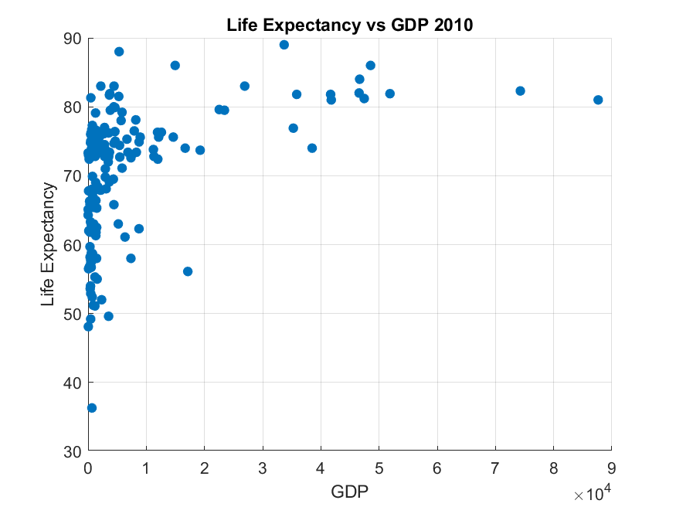

data2014 = readtable('C:\Users\hp\Desktop\GROUP 5 assignment 2\life.xlsx','Sheet','2014');
%Define East African countries
eastAfrica = {'Uganda','Burundi','Kenya','Rwanda'};

% filtering the rows
isEastAfrica = ismember(data2014.Country,eastAfrica);
eastAfricaData = data2014(isEastAfrica,:);

%the bar graph
bar(categorical(eastAfricaData.Country),eastAfricaData.Population);
xlabel('Country')
ylabel('population')
title('Population of African countries in est africa - 2014')
grid on
saveas(gcf, 'EastAfrica_Population_2014.png')

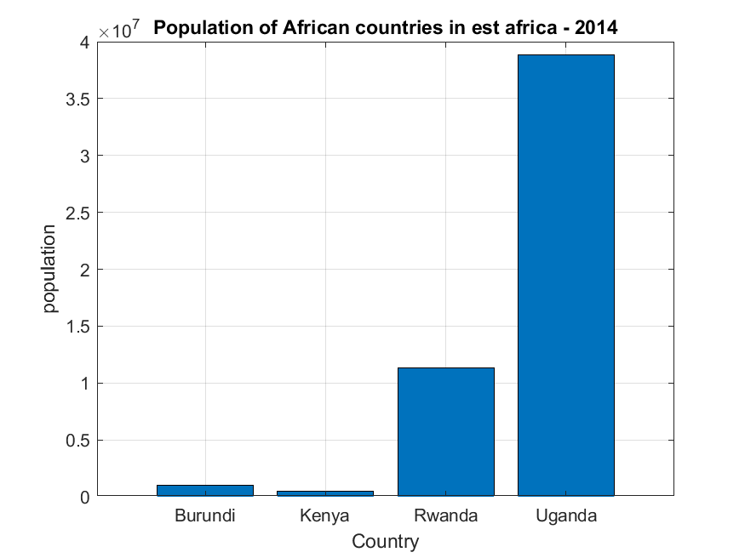

if ~isnumeric(eastAfricaData.Population)
eastAfricaData.Population = str2double(eastAfricaData.Population);
end

% Extract population
populations = eastAfricaData.Population;

% Calculate statistics
meanPop = mean(populations, 'omitnan');
medianPop = median(populations, 'omitnan');
stdPop = std(populations, 'omitnan');
minPop = min(populations);
maxPop = max(populations);

% Display results
fprintf('----Statistics of the East African Popultion---\n');
fprintf('Mean population: %.0f\n', meanPop);
fprintf('Median population: %.0f\n', medianPop);
fprintf('Standard deviation: %.0f\n', stdPop);
fprintf('Minimum population: %.0f\n', minPop);
fprintf('Maximum population: %.0f\n', maxPop);

%Reading data from 2008, sheet alcohol consumption with east african
%countries.
% Read 2014 data
data2008 = readtable('C:\Users\hp\Desktop\GROUP 5 assignment 2\life.xlsx', 'Sheet', '2008', 'VariableNamingRule', 'modify');

% East African countries
eastAfrica = {'Uganda', 'United Republic of Tanzania', 'Rwanda', 'Kenya'};

% Filter rows for East African countries
isEastAfrica = ismember(data2008.Country, eastAfrica);
eastAfricaData = data2008(isEastAfrica, :);

% Convert Alcohol data to numeric if needed
if ~isnumeric(eastAfricaData.Alcohol)
eastAfricaData.Alcohol = str2double(eastAfricaData.Alcohol);
end

% Extract Alcohol consumption and countries
alcoholConsumption = eastAfricaData.Alcohol;
countries = eastAfricaData.Country;

% Plot pie chart
figure
pie(alcoholConsumption, countries)
title('Alcohol Consumption in East African Countries (2008)')
% Save image
saveas(gcf, 'EastAfrica_Alcohol_Pie_2014.png')

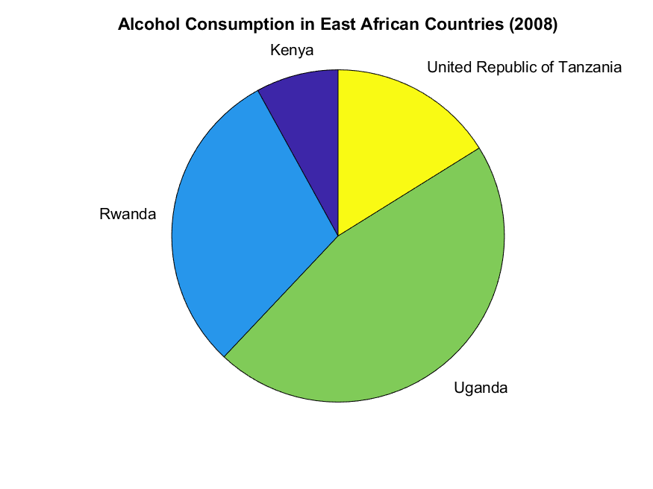

%obtain the data
data2012 = readtable('C:\Users\hp\Desktop\GROUP 5 assignment 2\life.xlsx', 'Sheet', '2012','VariableNamingRule','modify');
numericData= data2012(:,{'Life_expectancy', 'AdultMortality', 'Alcohol';
'GDP', 'Population', 'infantDeaths'});
% Convert table to matrix
dataMatrix = table2array(numericData);
% Compute correlation matrix
corrMatrix = corr(dataMatrix, 'Rows', 'complete');
% Plot heatmap
heatmap(corrMatrix, ...
'XDisplayLabels', numericData.Properties.VariableNames, ...
'YDisplayLabels', numericData.Properties.VariableNames, ...
'Title', 'Correlation Heatmap');
saveas(gcf, 'HeatMap_2012.png')

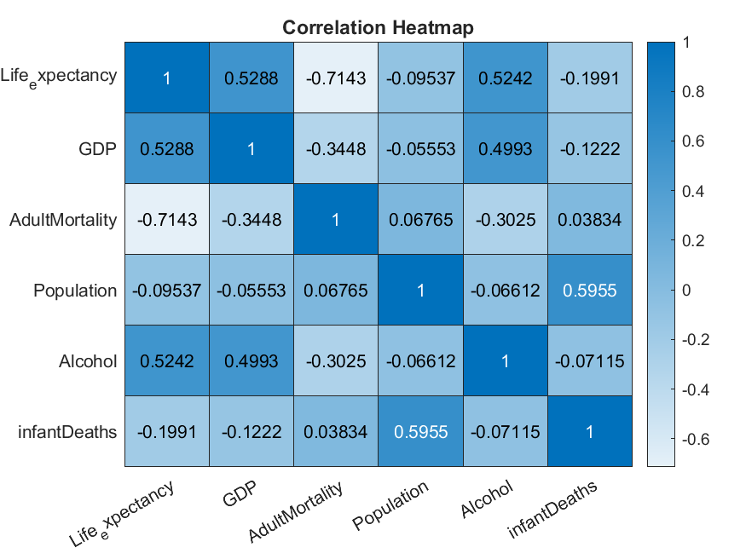

% Load the 2003 data
data2003 = readtable('C:\Users\hp\Desktop\GROUP 5 assignment 2\life.xlsx', 'Sheet', '2003', 'VariableNamingRule','modify');

% Extract relevant columns
GDP = data2003.GDP;
Alcohol = data2003.Alcohol;
LifeExp = data2003.Life_expectancy;

% 3D Scatter plot
figure;
scatter3(GDP, Alcohol, LifeExp, 50, LifeExp, 'filled');
xlabel('GDP');
ylabel('Alcohol Consumption');
zlabel('Life Expectancy');
title('3D Plot: Life Expectancy vs GDP and Alcohol (2003)');
colorbar;
grid on;
view(135, 30); % adjust view angle
saveas(gcf,'3D plot.png')

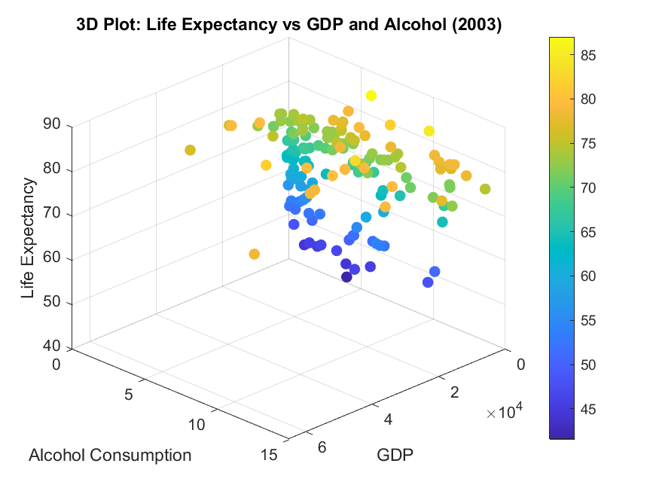

Explanation
For this assignment,we were required to use the first assignment of number 1,to visualise different patterns and trends using modules 1-4.
From the dataset ‘Life’ as used in assignment 1, patterns were made ,that is,finding the mean,median and plotting different graphs such as scatter diagram,bar graph,heat graph and many others as seen in the real code work handed in.All these were done by the comparison of East African countries ,that is,Burundi,Uganda,Kenya,Rwanda with their statistics in the data set.
These graphs,were then saved as images using this code;
% Save image
saveas(gcf, 'EastAfrica_Alcohol_Pie_2014.png')

2.0 CHAPTER TWO

2.1 NUMBER TWO
Each group has different members from different backgrounds, home districts, courses religions, tribes, villages, interests and facial representations.
a). Write a MATLAB code that can store each group member's affirmation attributes into a single variable ensure the code saves the variable.
Assignment two
b). From question two, utilize all knowledge from module one to module four to describe the different statiscal characteristics in the data and ensure to visualize them. Ensure that the different attributes or data collected per individual is detailed enough to describe them.
a)
% Defining struct
Members = struct('Name', {}, 'HomeDistrict', {}, 'Age', {}, 'Course', {}, ...
'Village', {}, 'Tribe', {}, 'Religion', {}, 'Interest', {}, 'FacialRepresentation', {});

% Member1
Members(1).Name = 'KemigisaTasha';
Members(1).HomeDistrict = 'Kampala';
Members(1).Age = 19;
Members(1).Course = 'AMI';
Members(1).Village = 'Kololo';
Members(1).Tribe = 'Mutooro';
Members(1).Religion = 'Christian';
Members(1).Interest = 'shopping';
Members(1).FacialRepresentation = imread('ngc6543a.jpg');

% Member2
Members(2).Name = 'AyebarePrudence';
Members(2).HomeDistrict = 'Mbarara';
Members(2).Age = 22;
Members(2).Course = 'WAR';
Members(2).Village = 'Mbarara';
Members(2).Tribe = 'Munyankore';
Members(2).Religion = 'Christian';
Members(2).Interest = 'Eating';
Members(2).FacialRepresentation = imread('ngc6543a.jpg');

% Member3
Members(3).Name = 'Kenyimoses';
Members(3).HomeDistrict = 'Jinja';
Members(3).Age = 21;
Members(3).Course = 'MEB';
Members(3).Village = 'buwenda';
Members(3).Tribe = 'kuku';
Members(3).Religion = 'Christian';
Members(3).Interest = 'swimming';
Members(3).FacialRepresentation = imread('ngc6543a.jpg');

% Member4
Members(4).Name = 'zzimbeenock';
Members(4).HomeDistrict = 'zana';
Members(4).Age = 21;
Members(4).Course = 'WAR';
Members(4).Village = 'masaka';
Members(4).Tribe = 'muganda';
Members(4).Religion = 'Christian';
Members(4).Interest = 'rapping';
Members(4).FacialRepresentation = imread('ngc6543a.jpg');

% Member5
Members(5).Name = 'oketchsimon';
Members(5).HomeDistrict = 'Jinja';
Members(5).Age = 22;
Members(5).Course = 'AMI';
Members(5).Village = 'kigaya';
Members(5).Tribe = 'musoga';
Members(5).Religion = 'Christian';
Members(5).Interest = 'football';
Members(5).FacialRepresentation = imread('ngc6543a.jpg');

% Member6
Members(6).Name = 'NakyagabaBabra';
Members(6).HomeDistrict = 'Busia';
Members(6).Age = 23;
Members(6).Course = 'ape';
Members(6).Village = 'buhayenji';
Members(6).Tribe = 'samia';
Members(6).Religion = 'Christian';
Members(6).Interest = 'watching';
Members(6).FacialRepresentation = imread('ngc6543a.jpg');

% Member7
Members(7).Name = 'PearlFlavia';
Members(7).HomeDistrict = 'Kazo';
Members(7).Age = 22;
Members(7).Course = 'WAR';
Members(7).Village = 'kashwa';
Members(7).Tribe = 'munyankole';
Members(7).Religion = 'Christian';
Members(7).Interest = 'playingvolleyball';
Members(7).FacialRepresentation = imread('ngc6543a.jpg');

% Member8
Members(8).Name = 'KagoyaAnnLauriene';
Members(8).HomeDistrict = 'Iganga';
Members(8).Age = 21;
Members(8).Course = 'PTI';
Members(8).Village = 'Iganga';
Members(8).Tribe = 'Musoga';
Members(8).Religion = 'Christian';
Members(8).Interest = 'WatchingMovies';
Members(8).FacialRepresentation = imread('ngc6543a.jpg');

% Member9
Members(9).Name = 'OyugiAndrewLinus';
Members(9).HomeDistrict = 'Kaberamaido';
Members(9).Age = 23;
Members(9).Course = 'WAR';
Members(9).Village = 'Okile';
Members(9).Tribe = 'Kumam';
Members(9).Religion = 'Christian';
Members(9).Interest = 'WatchingMovies';
Members(9).FacialRepresentation = imread('ngc6543a.jpg');

% Member10
Members(10).Name = 'OmaliEmmanuel';
Members(10).HomeDistrict = 'Tororo';
Members(10).Age = 23;
Members(10).Course = 'WAR';
Members(10).Village = 'Mukuju';
Members(10).Tribe = 'Itesot';
Members(10).Religion = 'Catholic';
Members(10).Interest = 'Football';
Members(10).FacialRepresentation = imread('ngc6543a.jpg');

b)
% Histogram of ages
age = [Members.Age]
histogram(age);
xlabel('Age');
ylabel('Count');
title('Age Distribution of Members');

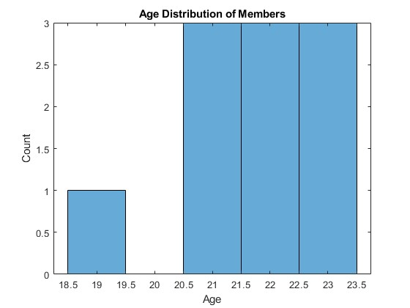

% Interest Comparison
interests = {Members.Interest}; uniqueInterests = unique(interests); counts = zeros(size(uniqueInterests));
for i = 1:length(uniqueInterests); counts(i) = sum(strcmp(interests, uniqueInterests{i})); end
figure; bar(counts); xticklabels(uniqueInterests); xlabel('Interest'); ylabel('Count'); title('Interests');

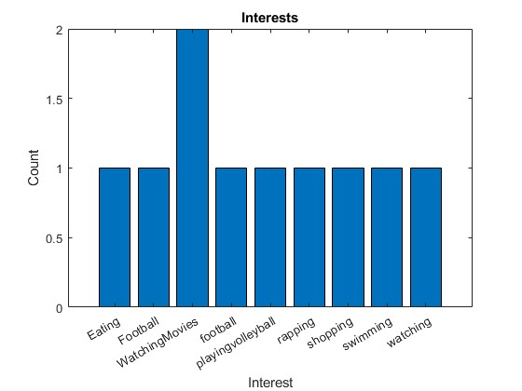

%Tribe Distribution
tribes = {Members.Tribe}; uniqueTribes = unique(tribes); counts = zeros(size(uniqueTribes));
for i = 1:length(uniqueTribes); counts(i) = sum(strcmp(tribes, uniqueTribes{i})); end
figure; pie(counts, uniqueTribes); title('Tribe Distribution');

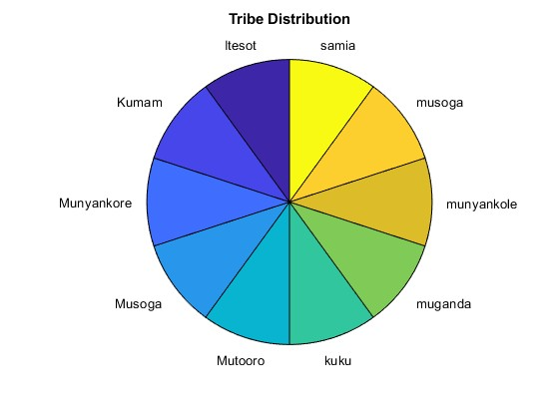

% Religion Distribution
religions = {Members.Religion}; uniqueReligions = unique(religions); counts = zeros(size(uniqueReligions));
for i = 1:length(uniqueReligions); counts(i) = sum(strcmp(religions, uniqueReligions{i})); end
figure; bar(counts); xticklabels(uniqueReligions); xlabel('Religion'); ylabel('Count'); title('Religion Distribution');

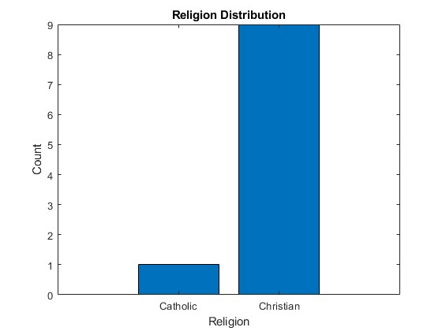

% Tribe vs Interest
uniqueTribes = unique(tribes); uniqueInterests = unique(interests); data = zeros(length(uniqueTribes), length(uniqueInterests));
for i = 1:length(Members); tribeIdx = find(strcmp(uniqueTribes, Members(i).Tribe)); interestIdx = find(strcmp(uniqueInterests, Members(i).Interest)); data(tribeIdx, interestIdx) = data(tribeIdx, interestIdx) + 1; end
figure; bar3(data); xlabel('Interests'); ylabel('Tribes'); zlabel('Count'); xticklabels(uniqueInterests); yticklabels(uniqueTribes); title('Tribe vs Interest');

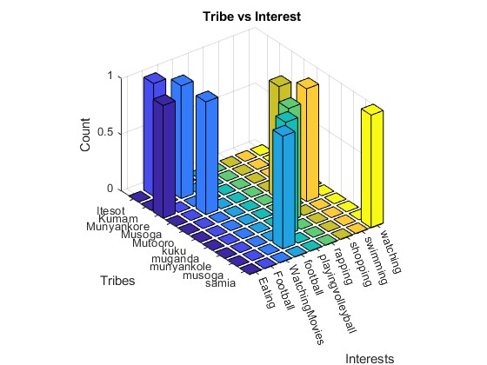

% District vs Age
figure;
boxplot([Members.Age]), categorical({Members.HomeDistrict});
xlabel('District');
ylabel('Age');
title('District vs Age');
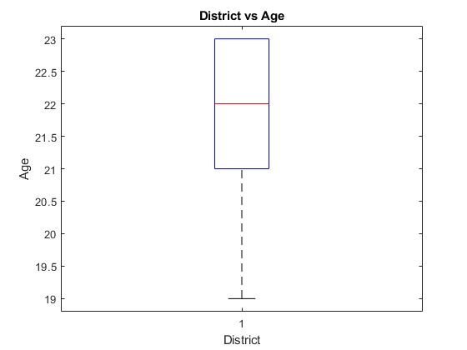

% Tribe vs Religion
uniqueTribes = unique(tribes); uniqueReligions = unique(religions); data = zeros(length(uniqueTribes), length(uniqueReligions));
for i = 1:length(Members); tribeIdx = find(strcmp(uniqueTribes, Members(i).Tribe)); religionIdx = find(strcmp(uniqueReligions, Members(i).Religion)); data(tribeIdx, religionIdx) = data(tribeIdx, religionIdx) + 1; end
figure; bar3(data); xlabel('Religions'); ylabel('Tribes'); zlabel('Count'); xticklabels(uniqueReligions); yticklabels(uniqueTribes); title('Tribe vs Religion');

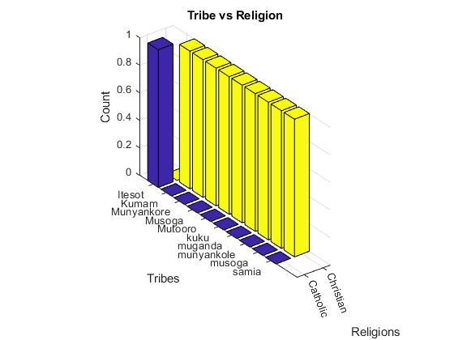

Explanation
The question required us to write a matlab code that could store each group member’s attributes into a single variable. So we wrote a code using %Defining struct which gave us the code below and then we proceeded to part b) which required us to visualize the different statiscal characteristics, we used the code generated to make the plots and below is their code.

3.0 CHAPTER THREE

3.1 CONCLUSION
This report contains assignment 1 and 2 demonstrating the application of module 1 to 4.

